HK INSTITUTE OF VOCATIONAL EDUCATION
DEPARTMENT OF INFORMATION AND COMMUNICATIONS TECHNOLOGY

ITP4910 Software Development Project

LAB 08 – Use of MDI Froms
and C# Controls: MenuStrip, TabControl and DateTimePicker

Objectives:
- To create Parent forms and Child forms in a MDI application
- To use a MenuStrip to create menus in a Windows form
- To use a TabControl to define multiple pages in a form
- To use a DateTimePicker to allow the user to select a date of time.

In some applications, you may need a form containing the other. This is called Multiple-Document Interface (MDI) Application. One important component in MDI applications is the MDI parent form which is the form that contains the MDI child forms. Child forms are the "sub-windows" wherein the user interacts with the MDI application. Creating an MDI parent form is easy, both in the Windows Forms Designer and programmatically.

Menus expose functionality to your users by holding commands that are grouped by a common theme. The MenuStrip control is new to this version of Visual Studio and the .NET Framework and can be used easily to create menus in Windows Applications. The MenuStrip control also supports the multiple-document interface (MDI). You can also enhance the usability and readability of your menus by adding access keys, shortcut keys, check marks, images, and separator bars.

A TabControl is analogous to the dividers in a notebook or the labels in a file cabinet. By using a tab control, an application can define multiple pages for the same area of a window or dialog box. Each page consists of a certain type of information or a group of controls that the application displays when the user selects the corresponding tab.

The Windows Forms DateTimePicker allows the user to select a single item from a list of dates or times. A DateTimePicker appears in two parts: a drop-down list with a date represented in text, and a grid that appears when you click on the down-arrow next to the list.

- Create a new project of type Windows Applications. Enter Lab08 as its name.

- Download a database ITP4910-Lab08-DB.zip. Unzip the file lib.accdb from it and copy lib.accdb to the bin\debug directory of your project.

- Add to Form1 a DataSource which connects to lib.accdb.

- To make Form1 a container for other forms, set

Form1.IsMdiContainer = true

- Add a MenuStrip control to Form1 and add two menu items with text "Enter Customer Info " and "View books "

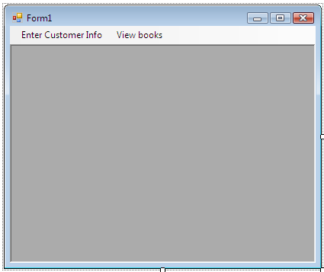

- Add two public variables to Form1 as follows:

public partial class Form1 : Form {
public string Address { get; set; }
public string SendDate { get; set; }

private Form2 frm2;
private Form3 frm3;

…
}

- Add two more Windows forms Form2 and Form3. Add private field and modify the constructor as following:

private Form1 frm1;

public Form2(Form1 frm) {
InitializeComponent();
this.frm1 = frm;
}

- In Form 1, double click the Enter Customer Info menu item and add the following code:

private void enterCustomerInfoToolStripMenuItem_Click(...) {
frm2 = new Form2(this);
frm2.MdiParent = this;
frm2.Dock = DockStyle.Fill;
if (frm3 != null)
frm3.Close();
frm2.Show();
}

- Do the same for the View books menu item, but use Form3 instead of Form2.

- Add a TabControl to Form2 and create two tabs (with text address and send date) as follows.
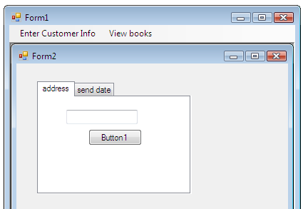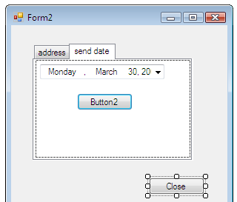

- Add a textbox and a button to the address tab. Add a DateTimePicker control and a button to the send date tab.

- Add a button to Form2 outside the tab control area. Change the text of button to “Close”.

- Add the following code to button1, button2, and button3.

private void button1_Click(object sender, EventArgs e) {
frm1.Address = textBox1.Text;
}

private void button2_Click(object sender, EventArgs e) {
frm1.SendDate = dateTimePicker1.Value.ToShortDateString();
}

private void button3_Click(object sender, EventArgs e) {
Close();
}

- Click “Show Data source” and drag the Books table onto Form3.

- Add a label to Form3.

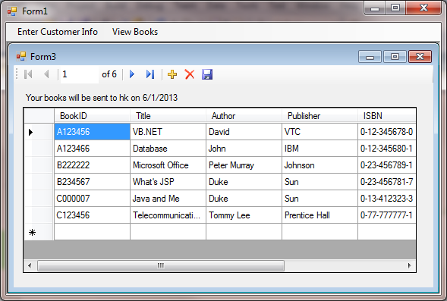

- Add the following code to the Form_load event of Form3.

private void Form3_Load(object sender, EventArgs e) {
...

label1.Text = "Your books will be sent to " +
frm1.Address + " on " + frm1.SendDate;
}

- Run your application. Click on the Enter Customer Info menu item. Click on the address tab. Enter hk in the text box and click button1. Click on the send date tab. Select 1 June 2013 from the DateTimePicker and click button2. Click on the View books menu item to see the result.

